37.9: 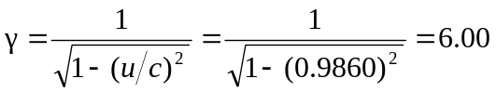
a) 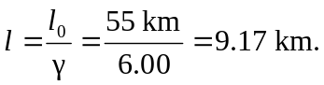
b) In muon’s frame:
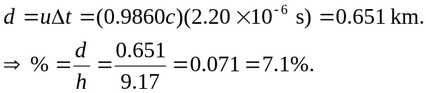
c) In earth’s frame:
